Strang effect

1. Voltage on the band diagram

|  |  |  |
| --- | --- | --- |
| -1 | 0 | 0.25 |
|  |  |  |
| 0.5 | 0.75 | 1.0 |
|  |  |  |

So the absorption is very sharp.

EF > E111

EF < E111

Band filling effect

2.

QCSE Effect

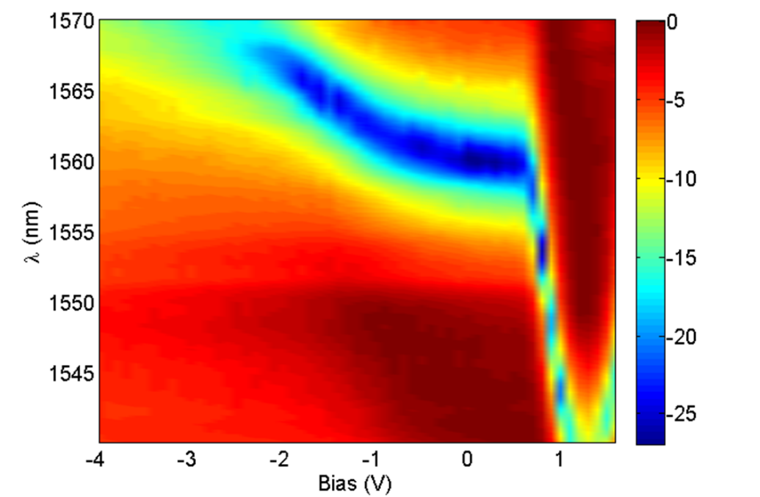

The significant blue shift of the absorption edge in the forward bias region is due to the band filling by 2D electron gas. The free carriers present in the quantum wells fill the lowest confined states up to EF. Light absorption is associated only with the transitions to unoccupied electronic states. So, one may expect the absorption edge to be shifted towards higher energies than the undoped QW and the energy shift ΔE = (1+me/mh)EF is proportional to F. It is very important to achieve low driven voltage modulator.

EF=(πℏ2/m)*Ns

EF = 2Ndx*(πℏ2/m)*2 – 2kTIn2 +E111

$$\frac{dλ}{dVoltage}=-\frac{λ^{2}d_{x}ℏτη}{c_{0}m^{*}qV}dI/ dV$$

λ is operation wavelength, dx is the width of the well, η is the injection current efficient, τ is the carrier lifetime, m* is the electron effective mass in well, V the volume in the active region.

3. Improve Speed

Speed limitation. Carrier lifetime.

Improve speed, MQW doping, reverse bias, reduce the carrier lifetime.

MQW doping, 3.2103e+017, EF is equal to E111 3.2127e+017 move 50nm

Paper content

Section 1. introduction

Section 2. 器件结构 图1

Section 3. band filling effect 理论

仿真结果 图2

Section 4．Device characteristics

和仿真结果比较的图3

Section 5．眼图.

Lowe driven voltage,

High driven voltage, Eye diagram, (2 speed)

Figure 2.

Absorption diagram (wavelength, voltage). 1,2

Experimental results